JAX-CMS Database Conversion Tool

Installing the Conversion Tool
If you wish to use JAX-CMS with a MySQL version of the JAX-CMS database, you must first install JAX-CMS. It is recommended that you install the latest version of JAX-CMS prior to converting your database. You must also have access to a MySQL database. If you do not, you may follow the instructions below to install MySQL. The next step is to download the conversion tool installation package by clicking here. You may either save the file to your local machine and then run it, or select “Run” directly from the link. When you run the installation package, you will be prompted with three screens like the one below:

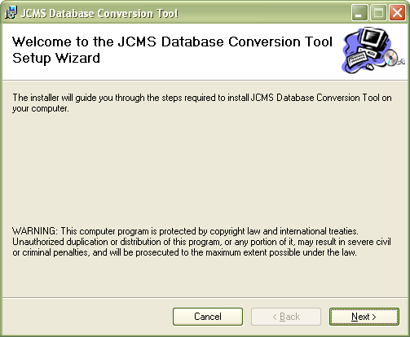

Click the “Next” button on each of these screens. The tool will then install on your computer and when it is finished, you will see an “Installation Complete” screen. Click “Close.” The next step in the installation is the setup of the MySQL driver, you will see the following window:

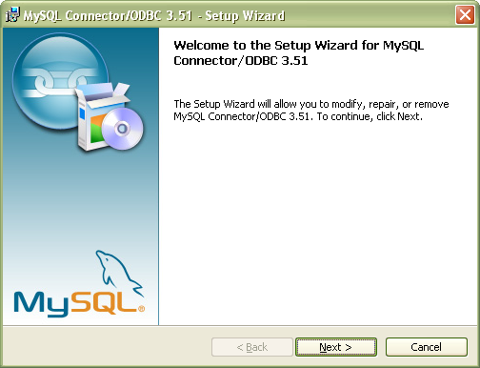

Click “Next” and on the next screen, leave the default setup type to “Typical” and click “Next.” On the following screen, click “Install.” The driver is then installed and the final screen will indicate that the install is complete. You are now ready to run the conversion tool.

Preparing your Access database
Prior to running the Conversion Tool, you need to prepare your Access database by setting the correct permissions. To do this, open your interface database (JCMS.mdb) and take the following steps:

- Go to the “Tools” menu and select “Security” and then “User and Group Permissions.”
- Highlight <New Tables/Queries> from the “Object Name” list on the right hand side
- Check the “Administer” check box and click “OK.”

Running the Conversion Tool
After installing it, you may start the conversion tool at any time by clicking Start -> Program Files -> JAX-CMS -> JAX-CMS Database Conversion Tool. You will see the following screen:

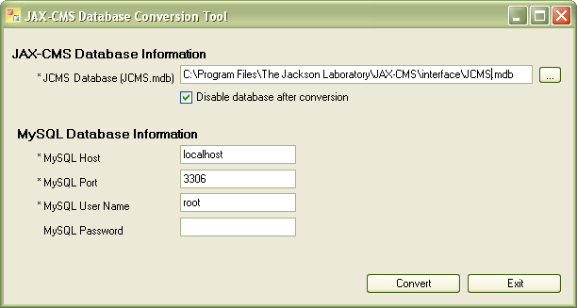

This is where you enter the location of your JAX-CMS interface database and log in information for your MySQL database. You also have the option of disabling your database after it is converted. This action renames the database by appending “.disabled” to the file name. Your data remain intact and the database may be restored by removing the “.disabled” from the file name. After you have entered this information, click “Convert.” You will then see a screen indicating each step performed and the overall progress of the conversion, for example:
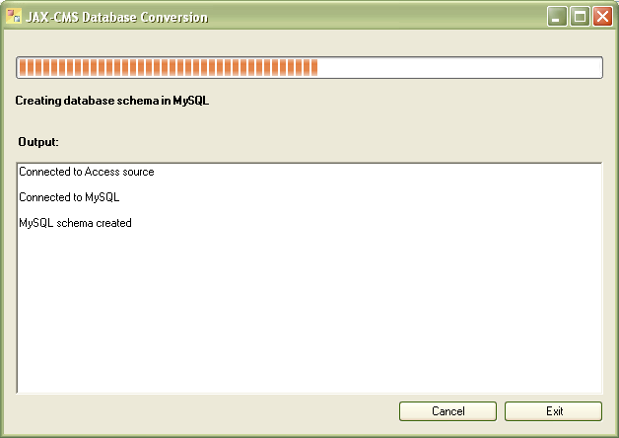

If for some reason your database conversion fails, a message will be provided, indicating the cause of the failure. If this happens, you may still use your JAX-CMS Access database, as this process DOES NOT affect your existing database.

Troubleshooting problems with database conversion
- Message “Error creating table <table name>”
  - This means that the table could not be created in MySQL and could be due to special characters in the table name. Check for and remove any special characters (such as question marks) and then attempt the conversion again.
- Message “Could not re-create table links. This step must be performed manually.”
  - This message indicates that the MySQL database was created and is ready for use, but you must manually recreate the links from your JAX-CMS.mdb by performing the following steps
    - Bring up JAX-CMS
    - Hit F11
    - Right click on the “ Tables” icon in the “ Objects” dialog
    - Select “Link Tables ..”
    - Select “ODBC databases” in the “Files of type” drop down list
    - In the “Select Data Source” window that appears, click to select “myJCMS.dsn” from the list and click “OK”
    - If prompted, enter log in information for your MySQL database
    - Select all tables except those starting with “mysql.” Make sure the “Save password” check box is checked, and click “OK.”
    - The tables will import, if you receive a “Select unique identifier” message box for any of the tables, just click “OK.”
    - Restart JAX-CMS

Instructions for downloading and installing MySQL

Point to http://dev.mysql.com/downloads/ in your web browser. In the section listed "MySQL Community Edition," click the link designated as the current release.

Select the install package for the platform you own. If you are a Windows owner, simply select the "pick a mirror" link to the right of the text that says "Windows (x86)."

Follow the instructions and select a mirror near to your geographic location. Click the link to download the file and save it onto your computer.

Using a zip extraction program such as WinZip, the free 7-Zip, or the program that comes with Windows, extract the files from the zip to another folder.

Access the folder you created and double click setup.exe.

Follow the instructions for the installation and when you reach the final prompt that reads "configure mysql server now," check the box next to it. Click Finish.

Now we have finished the installation and will begin the configuration. Click "Next."

Click the radio button next to "Standard Configuration" and click "Next."

Check the "Install As Windows Service" and "Launch the MySQL Server Automatically" checkboxes. Click "Next".

Now you need to create a root password you will need to access your server. Type in a password that is not easy to guess and make sure the "enable root access from remote machines" is checked. Click "Next."

On this window, click "Execute" to start MySQL and click "Finish."

To ensure that MySQL is properly installed, go to your task bar and go to "Start" > "All Programs" > "MySQL" > "MySQL Server 5.0" > "MySQL Command line client."

